**Project Title : customer feedback**

Login Page :

Login Validations:

Registration Page :

Registration Page Validation:

Cancel Registration here will redirect to Login Page…

After login success based upon the user type by using lazy loading concept and routing concept page redirection is happened based on user type.

Admin landing page :

Admin’s FeedBack Page:

Admin Submit Feedback Page:

Admin Submit FeedBack Page Validations:

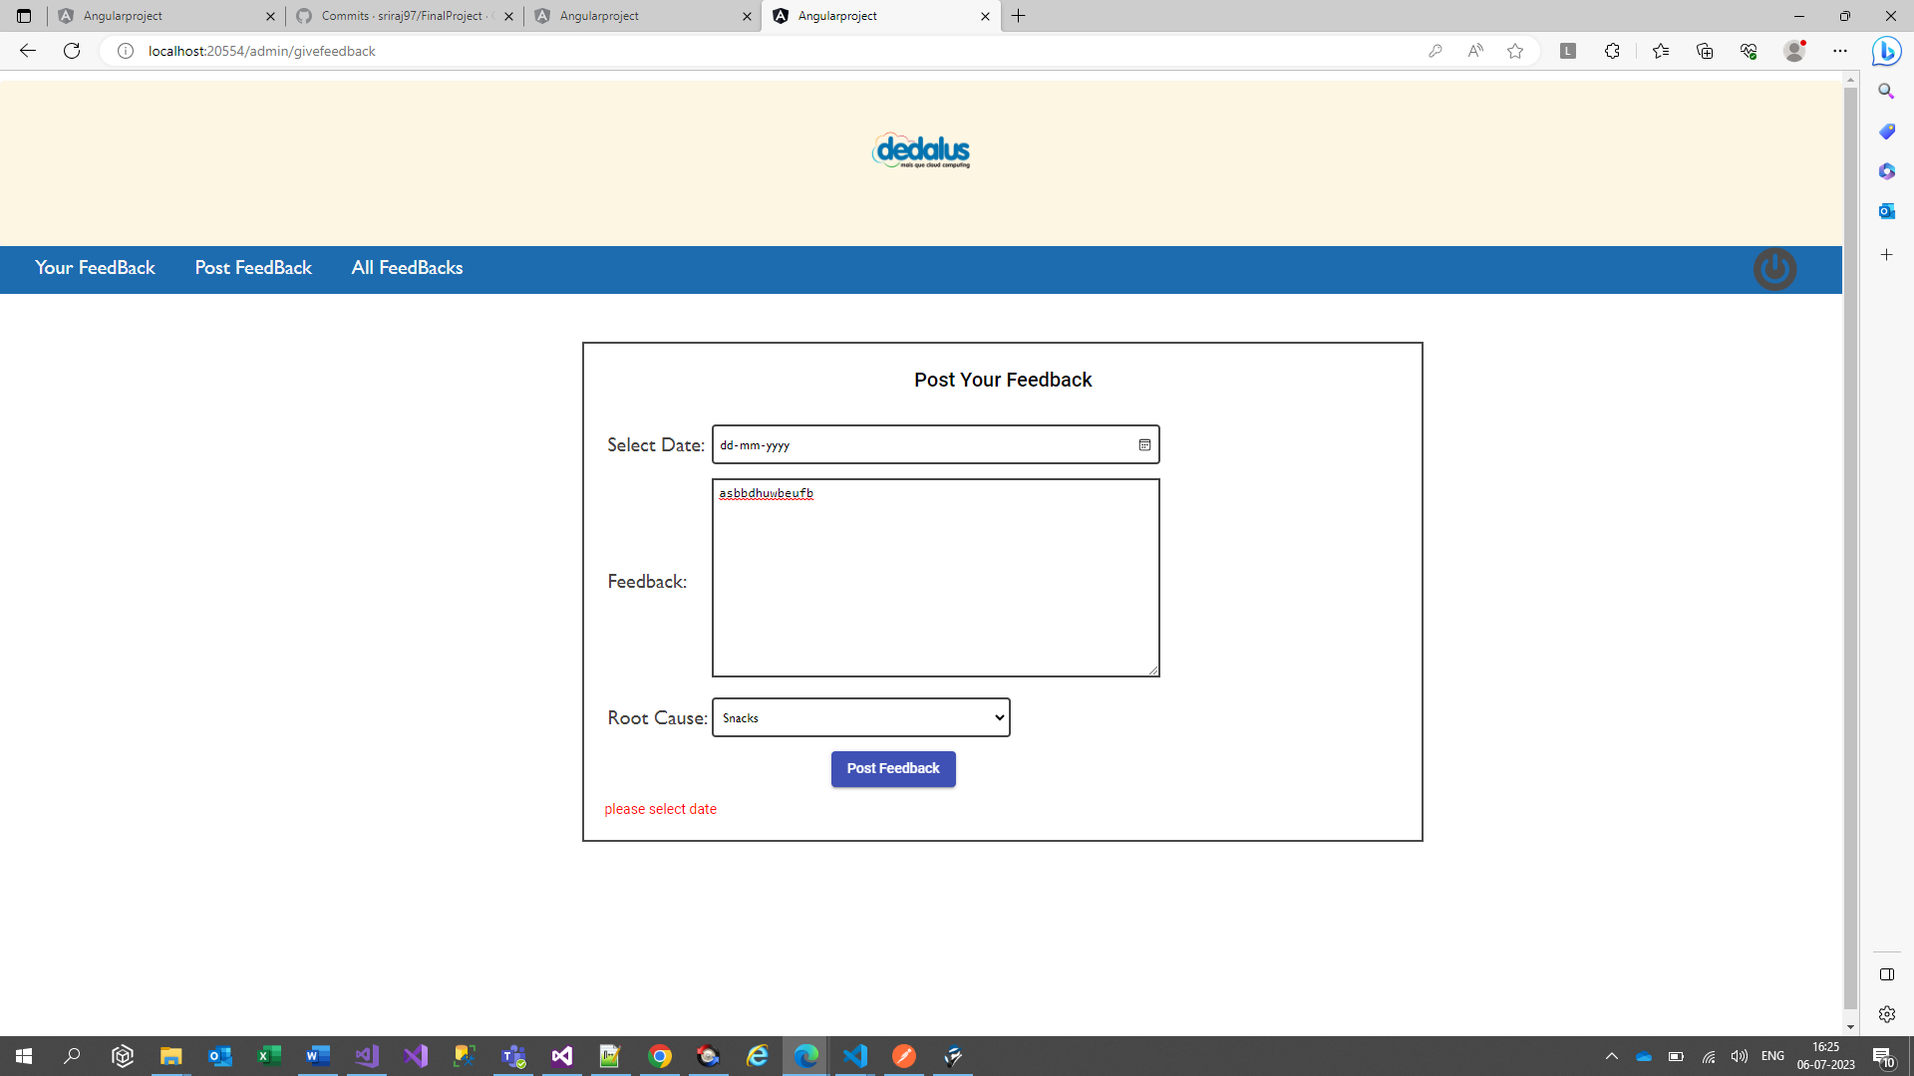

Admin Feedback submitted successfully:

All Users Feedback Except Admin’s Page:

LogOut button:

Logout page clears all current users session value and redirect to Login Page.

User Landing Page:

Users Feedback Page:

User Feedback Submission Page:

User Feedback submit Validations:

